**10 SCIENCE 2016**

### BIOLOGY TEST TWO

Name: ______________________ Teacher: _____________________ Mark: /46

**Percentage: %**

**SECTION A: MULTIPLE CHOICE (20 marks)**

1. A B C D 11. A B C D

2. A B C D 12. A B C D

3. A B C D 13. A B C D

4. A B C D 14. A B C D

5. A B C D 15. A B C D

6. A B C D 16. A B C D

7. A B C D 17. A B C D

8. A B C D 18. A B C D

9. A B C D 19. A B C D

10. A B C D 20. A B C D

**Answer question 1 and 2 using the information and table below.**

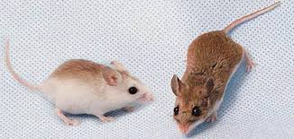

A biologist was studying a population of mice that lived in an area with few trees and scattered low shrubs separated from each other by large areas of bare soil. He found that the mice had two genes that controlled their coat colour. One tended to give the coat a dark-brown colour, while the other produced a lighter yellowish brown colour.

The area contained three different soil types: dark red clay, pale yellow sand and light grey sand. Studies of the proportion of mice with the different coat colour were done and are shown in the table. There was a very dry semi-desert climate and the mice were preyed upon by hawks that hunted mainly in the morning and late afternoon.

|  |  |  |  |
| --- | --- | --- | --- |
| Site | Soil colour | Per cent of mice with brown coat | Per cent of mice with yellowish coat |
| 1 | Red | 82 | 18 |
| 2 | Light grey | 52 | 48 |
| 3 | Pale yellow | 41 | 59 |

**1.** Which of the following is a fair interpretation of the data?

(a) There are more brown-coated mice than yellow-coated mice in the population.

(b) Brown coats are more suited to red clay than they are to light-grey sand.

(c) Yellowish coats are more suited to the light-grey sand.

(d) Brown-coated mice are moving from pale-yellow sand and light-grey sand to the red clay.

**2.** Considering the information in the table, which of the following conclusions is likely?

(a) Hawks always prefer to eat mice with a yellowish coat colour.

(b) The climate is selecting for lighter coloured mice because they will absorb less heat.

(c) The coat colour provides the mice with camouflage protection from the hawk.

(d) Light colour soil selects for the yellowish coat colour.

**3.** Choose the genotype of a homozygous individual.

(a) r.

(b) RR.

(c) Rr.

(d) R.

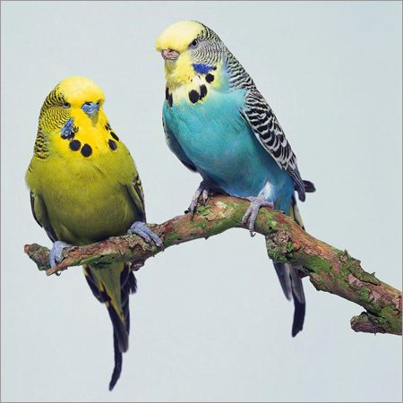**4.** In budgerigars, green feather colour (G) is dominant to blue feather colour (g). A

blue male budgerigar is mated with a heterozygous female budgerigar. Identify

the most probably genotypes of the offspring.

(a) All the offspring will be blue.

(b) All the offspring will be green.

(c) ½ Gg, ½ gg.

(d) ½ GG, ½ gg.

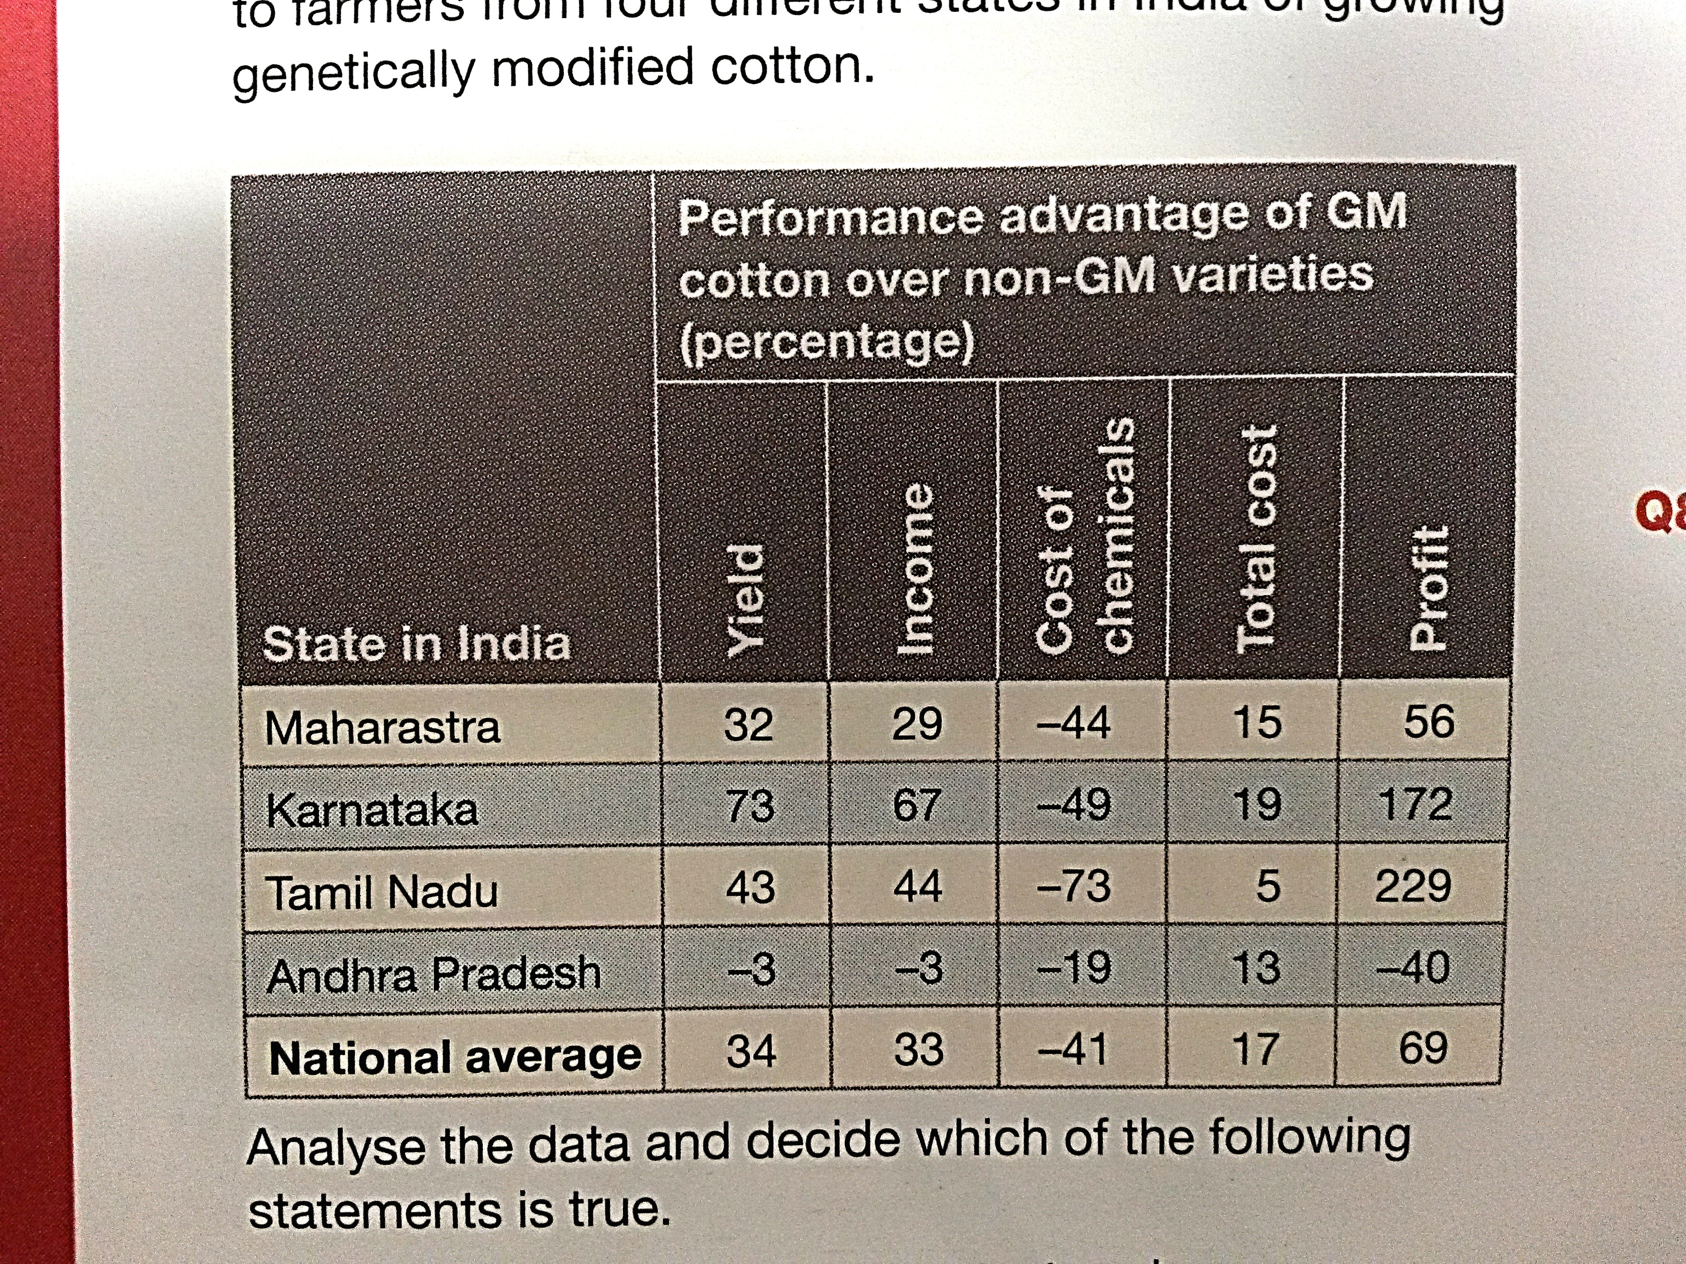**5.** The data in the table provides information on the

costs to farmers from four different states in

India of growing genetically modified cotton.

Analyse the data and decide which of the following statements is true.

(a) The state that made the greatest savings on chemicals also had the highest yield and greatest profit.

(b) The states of Maharastra and Kamataka both saved more than the national average on chemical costs and had a yield and profit above the national average.

(c) The state that had the greatest advantage in terms of total income also had the greatest advantage in terms of total cost and yield.

(d) Andhra Pradesh made a loss because the farmers in that state had to spend more on chemicals.

**6.** What is likely to happen to an individual that is poorly suited to its environment?

(a) It will not survive to reproduce.

(b) It will survive and produce lots of successful offspring.

(c) It will become extinct.

(d) It will to grow to an old age.

**7.** According to Darwin’s theory of evolution, how do new species evolve?

(a) By artificial selection.

(b) Variation.

(c) By natural selection.

(d) By unnatural selection.

**8.** Which individuals are most likely to survive to reproduce?

(a) Individuals that are well suited to their environment.

(b) Individuals that are poorly suited to their environment.

(c) Individuals that have no immunity to new diseases.

(d) Individuals that have resistance to mutations.

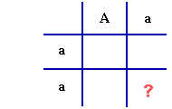**9.** Select the genotype that belongs in the section marked by a “?”.

(a) aa.

(b) aA.

(c) AA.

(d) Aa.

**10.** If two people who are both carriers for a genetically inherited fatal recessive disease decide to

become parents, what will be the odds that their children will also be carriers?

(a) 1 out of 4.

(b) 2 out of 4.

(c) 3 out of 4.

(d) 4 out of 4.

**11.** If two parents are heterozygous for a genetically inherited dominant trait, what is the

probability that they will have a child together who has this trait in his or her phenotype?

(a) 25%.

(b) 50%.

(c) 75%.

(d) 100%.

**12.** If two parents are homozygous for a genetically inherited recessive trait, what is the probability

that they will have a child who does **not** have this trait in his or her phenotype?

(a) 0%.

(b) 25%.

(c) 50%.

(d) 100%.

**13.** In relation to natural selection, evolution is the:

(a) Process.

(b) Outcome.

(c) Mechanism.

(d) Purpose.

**14.** Through careful observation, Charles Darwin came to understand that:

(a) Populations of plants and animals in nature most often consist of individuals that are clones of each other.

(b) Those individuals whose variation gives them an advantage in staying alive long enough to reproduce are more likely to pass their traits on to the next generation.

(c) Populations of a species that become isolated from others by adapting to different environmental niches quickly become extinct.

(d) All of the above.

**15.** The example of the peppered moths living near English industrial cities demonstrates that:

(a) A change in the environment can result in the evolution of species living there.

(b) Evolution occurs so slowly that it is not possible to determine that it has happened in less than a million years.

(c) The environment near these cities has always favoured dark coloured moths.

(d) Moths are able to quickly adapt to the environment within a few hours.

**16.** Select the most correct definition of the term ‘fossils’.

(a) The evidence of a plant or animal in water from an earlier geological period.

(b) The evidence of a plant or animal in water from the future.

(c) The evidence of a plant or animal in rock from an earlier geological period.

(d) The evidence of a plant or animal in soil from the future.

**17.** What is the difference between natural selection and sexual selection?

(a) Natural selection is a type of sexual selection.

(b) Sexual selection is a type of natural selection.

(c) Sexual selection occurs during sex.

(d) None of the above.

**18.** The allele that masks (covers) the effects of the other is ______ and the masked allele is _______.

(a) Homozygous, heterozygous.

(b) Homozygous, recessive.

(c) Dominant, recessive.

(d) Dominant, incomplete.

**19.** Gregor Mendel believed that the characteristics of pea plants are determined by the:

(a) Inheritance of units from both parents.

(b) Inheritance or units from one parent.

(c) Relative health of the parent plants at the time of pollination.

(d) The amount of pollen available in the flowers.

**20.** Which of the following is **not** a source of variation in a population?

(a) Inherited genetic differences.

(b) Differences due to health.

(c) Difference due to age.

(d) None of the above.

**SECTION B: SHORT ANSWER (26 marks)**

**1.** **List** two examples of biotic selective factors. (2 marks)

______________________________________________________________________________________

**2.** **List** two examples of physical/abiotic selective factors. (2 marks)

______________________________________________________________________________________

**5.**

**3.** Spraying crops with pesticides has caused the development of pesticide-resistant insects. This is an example of natural selection even though humans are involved in the spraying.

**Identify** the selective agent for natural selection in this case. (1 mark)

______________________________________________________________________________________

**4.** The process where an environmental factor acts on a population and results in some organisms having more offspring than others is known as: (1 mark)

______________________________________________________________________________________

**5.** **Circle** either ‘true’ or ‘false’ for the following statements. (3 marks)

Mutations can be caused by mutagens. True False

Genes are inherited. True False

Characteristics that can be physically seen are known as genotypes. True False

**6.** **Explain** how the male determines the sex of the child. (3 marks)

______________________________________________________________________________________

______________________________________________________________________________________

______________________________________________________________________________________

______________________________________________________________________________________

______________________________________________________________________________________

______________________________________________________________________________________

______________________________________________________________________________________

______________________________________________________________________________________

______________________________________________________________________________________

**7.** The inherited ability of an organism to withstand chemicals is known as: (1 mark)

______________________________________________________________________________________

**8.**  In guinea pigs, black fur is dominant over brown fur. Show the cross of a heterozygous black male

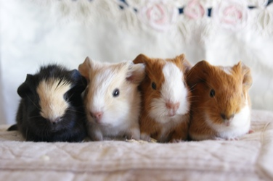 with a homozygous brown female. (5 marks)

**Parents**

Male genotype: _______________ Male phenotype: _________________________________

Female genotype: ______________ Female phenotype: _______________________________

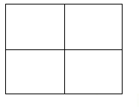

**Offspring**

Genotype: ______________________________________________________________________________

_______________________________________________________________________________________

Phenotype: _____________________________________________________________________________

_______________________________________________________________________________________

**9.** Write the correct letter next to the matching description. (8 marks)

|  |  |  |
| --- | --- | --- |
| Symbol/name | Description | Matching letter |
| **a)** Mm | A dominant allele |  |
| **b)** XY | Another name for gene |  |
| **c)** M | Genotype of a homozygous individual |  |
| **d)** PP | Genotype of a male individual |  |
| **e)** Red flower | Genotype of a heterozygous individual |  |
| **f)** a | Genotype of a female individual |  |
| **g)** XX | A recessive allele |  |
| **h)** Allele | A phenotype |  |

**Go back and read the questions and your answers.**

**Check your spelling and grammar.**

**Check that you had a go at every question.**